**Installation:**

Step 1:

Login to hosting (Linode, AWS, Azure)

Linode example:

1. Create Linode
2. Select Ubuntu 18.4
3. Select London as the Region
4. Specs depend on clients requirements. (Dedicated CPU recommended for clients)
5. Add a Linode Label & root password. (Make sure to make note of password)
6. Click Create Linode
7. Open Putty to SSH into the IP Address provided
8. Type in root password to connect to Linode box
9. Configure timezone -

*dpkg-reconfigure tzdata*

1. Install PHP prerequisites -

sudo apt -y install software-properties-common

sudo add-apt-repository ppa:ondrej/php

sudo apt-get update

1. Install required packages -

apt install apache2 libapache2-mod-php7.4 php7.4 unzip php7.4-xml php7.4-mysql php7.4-imap php7.4-zip php7.4-intl php7.4-curl php7.4-gd php7.4-mbstring php7.4-bcmath ntp -y

1. Install MariaDB 10.5 -

sudo apt-key adv --recv-keys --keyserver hkp://keyserver.ubuntu.com:80 0xF1656F24C74CD1D8

sudo add-apt-repository 'deb [arch=amd64,arm64,ppc64el] http://mirror.lstn.net/mariadb/repo/10.5/ubuntu bionic main'

sudo apt update

sudo apt install mariadb-server

1. Configure Apache2 -

sudo nano /etc/apache2/sites-available/mautic.conf

1. Run this command but replace highlighted with own domain name and directory root location -

<VirtualHost *:80>

ServerAdmin admin@yoursite.com

DocumentRoot **/var/www/html/mautic**

ServerName **yoursite.com**

<Directory /var/www/html/mautic/>

Options +FollowSymlinks

AllowOverride All

Require all granted

</Directory>

ErrorLog ${APACHE_LOG_DIR}/error.log

CustomLog ${APACHE_LOG_DIR}/access.log combined

</VirtualHost>

1. Add SSL -

sudo add-apt-repository ppa:certbot/certbot

apt update && apt upgrade -y

sudo apt-get install python-certbot-apache

1. Initiate Certbot setup -

certbot --apache -d subdomain.yourdomain.com

1. Enable it using the following -

sudo a2ensite mautic.conf

sudo a2enmod rewrite

1. Tweak PHP Settings -

sudo nano /etc/php/7.4/apache2/php.ini

1. Check the following settings -

file_uploads = On

allow_url_fopen = On

short_open_tag = On

memory_limit = 256M

upload_max_filesize = 100M

max_execution_time = 300

post_max_size = 200M

date.timezone = "Europe/Zurich"

1. Restart Apache -

sudo systemctl restart apache2.service

1. Create Database -

sudo mysql_secure_installation

1. When prompted, answer the following questions -

Enter current password for root (enter for none): Just press the Enter

Set root password? [Y/n]: Y

New password: Enter password

Re-enter new password: Repeat password

Remove anonymous users? [Y/n]: Y

Disallow root login remotely? [Y/n]: Y

Remove test database and access to it? [Y/n]: Y

Reload privilege tables now? [Y/n]: Y

1. Stop and restart the server -

sudo systemctl stop mariadb.service

sudo systemctl start mariadb.service

1. Log in to database -

CREATE DATABASE mauticdb;

1. Create database user -

CREATE USER 'mauticuser'@'localhost' IDENTIFIED BY 'YOURSTORNGPSW';

1. Grant full access to the user -

GRANT ALL ON mauticdb.* TO 'mauticuser'@'localhost' IDENTIFIED BY 'YOURSTRONGPSW' WITH GRANT OPTION;

1. Save changes & Exit -

FLUSH PRIVILEGES;

EXIT;

1. Download Mautic -

mkdir /var/www/html/mautic

cd /var/www/html/mautic

wget https://github.com/mautic/mautic/releases/download/4.0.0/4.0.0.zip

unzip 4.0.0.zip

rm 4.0.0.zip

1. Reset Ownership & Permissions -

sudo chown -R www-data:www-data /var/www/html/mautic/

sudo chmod -R 755 /var/www/html/mautic/

1. Reload Apache -

service apache2 reload

1. Setup Mautic - Fill in Database Setup
2. Fill in Admin User setup
3. Fill in Email Configuration

**Add users:**

Navigate to the settings icon in the top right, then click users.

Click new to add a new user, add their First Name, Last Name & email address. You can give the user a role to restrict them from certain parts of the system. A username and password will need to be assigned so that the user can log in to the system.

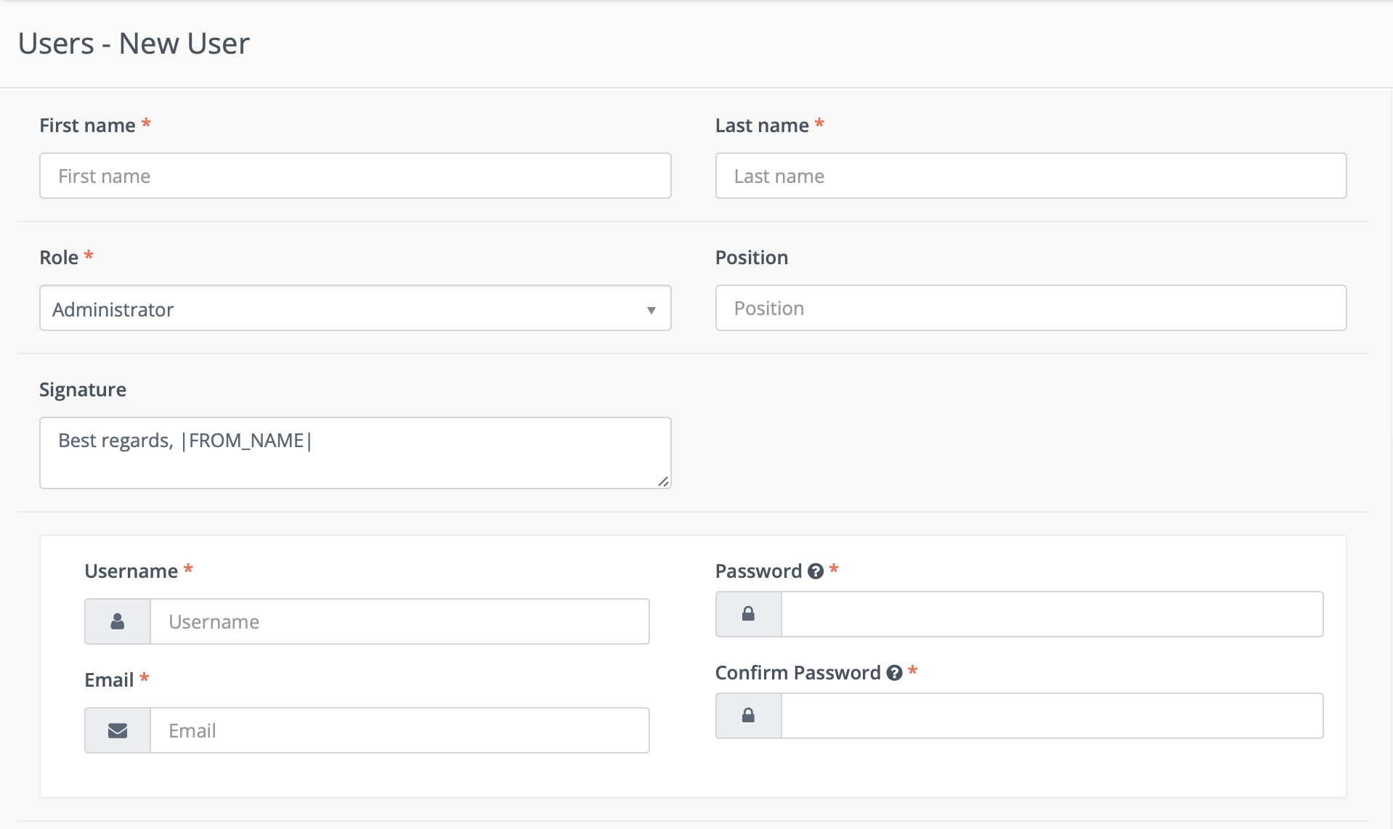

You can create different roles under the roles section.

New roles such as “Full System Access” can be created here.

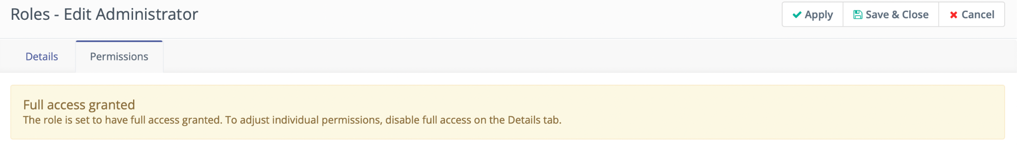

**Email Creation:**

Emails can be created to be used within campaigns and other list activities. Emails provide a means for direct interaction with potential customers, clients, and contacts.

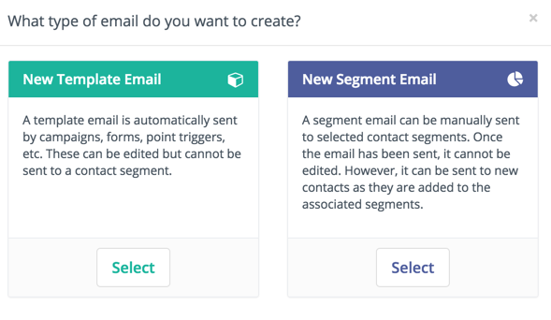

There are two types of emails: template and segment (broadcasts).

**Template Emails**

Template emails are transactional by default and can be used in campaigns, form submit actions, point triggers, etc. These can be sent to the same contact as many times as needed. These cannot be sent to a contact outside of another Mautic component except when sending an email directly to a contact in which the content is cloned (template emails sent directly to a contact are not associated with the template email itself and thus stats are not tracked against it).

**Segment (Broadcast) Emails**

These are marketing emails by default. Segments are assigned to the email which will determine which contacts receive the communication. Note that each contact can only receive the email once - it's like a mailing list.

Initiating these emails can be done in one of two ways. Prior 2.2.0, sending had to be manually initiated through the UI as an ajax process batched over the contacts. As of 2.2.0, a new cron job is available to do this for you! See [Send Scheduled Broadcasts (e.g. segment emails)](https://docs.mautic.org/en/setup/cron-jobs#send-scheduled-broadcasts-e-g-segment-emails) for more details on this.

**Email Formats**

Emails can be created in both full HTML as well as basic text format to be delivered as necessary to contacts. This is an important part of creating a strong relationship with contacts by providing relevant information in the correct format.

**Email Delivery**

Emails are delivered using the method defined by the system administrator. You will need to add the email protocol to use. Mautic integrates with any email service provider which offers SMTP mail servers as well as several distinct services such Sparkpost, [Mandrill](https://mandrill.com/), [Gmail](https://gmail.com/), [Sendgrid](https://sendgrid.com/), [Mailjet](https://app.mailjet.com/signup?utm_source=mautic), [Postmark](https://postmarkapp.com/), [Sendmail](https://www.sendmail.com/) and [Amazon SES](https://aws.amazon.com/ses/).

The system can either send emails immediately or queue them to be processed in batches by a cron job.

**Immediate Delivery**

This is the default means of delivery. Mautic sends the email as soon as it is instructed to by the triggering action. If you expect a large number of emails to be sent, then utilizing the queue is recommended. Sending email immediately may slow the response time of Mautic if using a remote mail service since Mautic has to establish a connection with that service before sending the mail. Also attempting to send large batches of emails at once may hit your server's PHP limits or email limits if on a shared host.

**Queued Delivery**

This is recommended if you plan to send a significant number of emails. Mautic will store the email in the configured spool directory until the command to process the queue is executed. Set up a cron job at the desired interval to run the command:

**php /path/to/mautic/bin/console mautic:email:process --env=prod**

Some hosts may have limits on the number of emails that can be sent during a specified timeframe and/or limit the execution time of a script. If that's the case for you, or if you just want to moderate batch processing, you can configure batch numbers and time limits in Mautic's Configuration.

**Email Fields**

You have access to any number of contact fields to be used in your form emails. These can be easily placed within your emails and will be automatically replaced with the appropriate text once the email is sent.

**Tracking Opened Emails**

Each email sent through Mautic is tagged with a tracking pixel image. This allows Mautic to track when a contact opens the email and execute actions accordingly. Note that this technology is limited to the contact's email client supporting HTML and auto-loading of images. If the email client does not load the image, there is no way for Mautic to know if the email was opened.

By default, the tracking pixel image is added at the end of the message, just before the **</body>** tag. If needed, one could use the **{tracking_pixel}** within the body content token to have it placed elsewhere.

**Tracking trackable links in emails**

Clicks of each link in an email are tracked and those clicks count can be found at the bottom of email detail page under Click Counts tab.

**Unsubscribing**

Mautic has a built in means of allowing a contact to unsubscribe from email communication. If using the builder, simply drag and drop the Unsubscribe Text or Unsubscribe URL tokens into your email. Or insert **{unsubscribe_text}** or **{unsubscribe_url}** into your custom HTML. The unsubscribe text token will insert a sentence with a link instructing the contact to click to unsubscribe. The unsubscribe URL token will simply insert the URL into your custom written instructions.

**Online version**

Mautic manages also the hosting of an online version of the email sent. To use that feature, simply add the following as URL on text to generate the online version link **{webview_url}**.

**Managing emails**

**Email Overview**

The email overview allows at-a-glance information regarding the success or failure of a particular email. You can quickly see relevant information in regards to opens, bounces, successful click-throughs and other important statistics.

**Email Creation**

Email creation can be handled through the graphical email builder with little to no HTML knowledge. Emails are assigned to particular segments and/or campaigns. Below are some key steps to be performed when creating an email.

**Translations**

When creating the email, an option is given to assign a language and a translation parent. By selecting a translation parent, the current item is then considered to be a translation in the selected language of that parent item. If a contact has a preferred language set, they will receive the translated version in their preferred language if it exists. Otherwise, they will receive the parent in the default language.

It is also possible to have translations of A/B test variants.

**Segments**

When creating an email, you can select the segments to which you want to send the email.

This entry field is a multi-select which allows you to choose several segments if necessary.

**Email Builder**

The email builder is a graphical user interface to create an HTML email through the use of drag-and-drop tools.

Since **Mautic 2.7.0**, the builder will let you drag the predefined content sections from the right-hand toolbar and drop them to the position you choose. It's possible to select from layout of 1, 2 or 3 columns. The existing sections can be re-ordered or removed.

The email builder provides quick and convenient access to assets, landing pages, and other extra fields which are considered important or commonly used. All those are accessible via tokens in format {component=item}, for example **{contactfield=company}**. A drop-down with options will appear when you type **{** character and you can search for the right token by typing its name. For example, if you type **{comp**, it will suggest the right token for the Company Contact Field and you can select it via keyboard or by clicking on it.

Tokens can be used also for the Subject line, but there is no drop-down. You'll have to type it yourself or select it in the email body and copy-paste it to the subject field.

**Email Builder has also special tokens for the Unsubscribe link, Webview link and the Tracking pixel:**

**{unsubscribe_text}** - Creates a link with the unsubscribed URL and the textdefined in the Mautic configuration.

**{unsubscribe_url}** - Creates a URL to the unsubscribed page which can be used in a link's href attribute.

**{webview_text}** - Creates a link with the webview URL and the text defined in the Mautic configuration.

**{webview_url}** - Creates a URL to the webview page which can be used in a link's href attribute.

**{tracking_pixel}** - Creates a 1-pixel image that allows to track email open.

Since Mautic 3.1, a plain-text version of emails will be created when sent if one is not provided during the creation process.

**Contact token modifiers**

**Default value**

A token can have a default value for cases when the contact doesn't have the value known. The default value can be specified after | character like this: **{contactfield=company|Default text}**.

**Encoded value**

Embed the tokens as **{contactfield=FIELDALIAS|true}**. The |true tells Mautic to encode the value used for example in urls.

**Date format**

For custom date fields use:

* **{contactfield=DATEFIELDALIAS|datetime}**
* **{contactfield=DATEFIELDALIAS|date}**
* **{contactfield=DATEFIELDALIAS|time}**

Your date will displayed as human reading format taken from Configuration > System Settings

* **Default format for date only.**
* **Default Time Only Format.**

**Tracking Pixel**

The tracking pixel image is usually appended to the email message, if enabled. If needed, one could insert the tracking pixel image with the special token {tracking_pixel} at any place other within the text body. Beware that it should not be inserted directly after the opening <body> because this prevents correct display of pre-header text on some MUAs.

**Code Mode**

Code Mode is an option available in the Email and Page edit form. It will allow you to create/insert/edit your content in HTML code. It's helpful for situations where you don't want to use a Mautic theme and you want to use an HTML theme copied from a 3rd party theme builder or if you enjoy editing HTML code so much.

Code Mode was introduced in Mautic 2.3.0 and replaced the full page Froala (WYSIWYG) editor which manipulated the HTML code in some cases. Code Mode will not modify any of the code you paste in. The other option to edit a page/email content is to use the Builder. It uses Froala editor only to edit the text/image content, not the full page, so it won't modify the page layout.

**Select the Code Mode**

The Code Mode can be selected in the theme select after you create/edit the page/email. To open the Code Mode Builder after you select the Code Mode theme option, click the Builder button.

**Limitations**

If you use a Mautic theme to create the page/email and you want to edit the HTML code of it in the Code Mode Builder, you can do so, but you cannot switch back to the theme again. You will always have to edit the content in the Code Mode Builder. Selecting a theme will always refresh the content to the default theme HTML and so you'll lose your modifications.

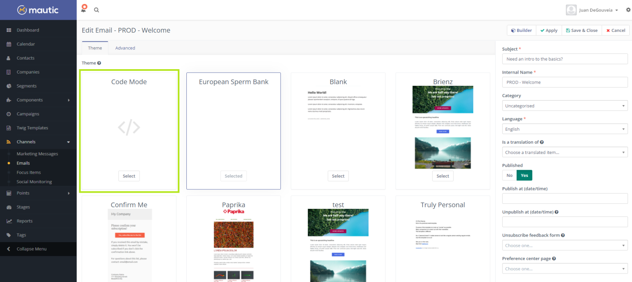

**Edit the HTML content in the Code Mode Builder**

When the Code Mode Builder is opened, you can see the preview on the left, the HTML code editor on the right. The preview will automatically refresh every 10 seconds if some change has been made to the code.

**Mautic Tokens**

You can use the tokens in the Code Mode Builder when you type them directly. For example, when you type **{contactfield=firstname}**.

**Media Manager**

There is a button at the top of code area where you can open the Media Manager to upload and/or select an image or other file. If you select a file, the URL of that file will be inserted to the current position of the cursor. Use this to create links and IMG tags.

**Code Formatter**

It might happen that your older emails or pages appear as HTML code on one line. Or if you insert an HTML code with odd formatting, use the Format Code button. It will automatically go through the code and format it so it is easier to navigate in it.

**Base64 Encoded Images**

Since Mautic 1.4, there is a new option in the Mautic configuration, the Email Settings tab. You can let Mautic encode all images in the email text as base64. It will attach the image inside the email body. It has several implications:

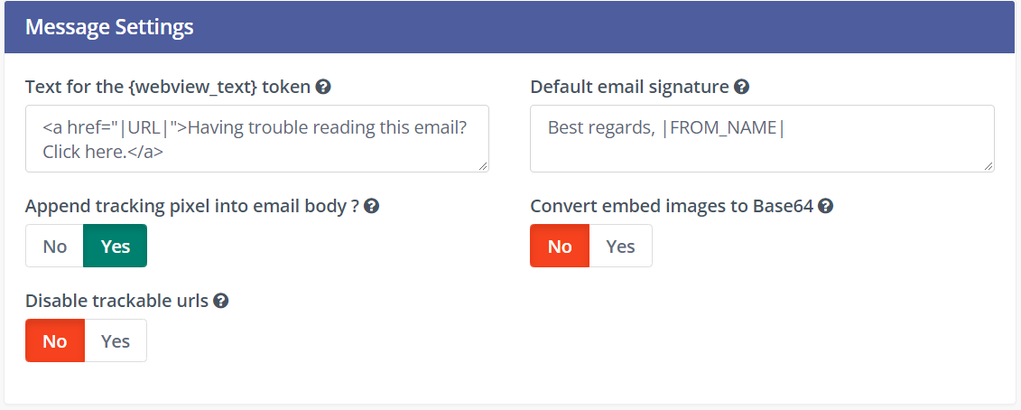

* The main idea with this option is that most of the email clients will display the images directly without any approvals.
* However, some email clients like Gmail will require the approval because of the tracking pixel and won't display the base64 encoded images anyway. See the next paragraph for possible solution.
* The email body will increase significantly if the email contains many and/or big images. Some email clients like Gmail will "clip" such email and won't display it directly.

**Disable the Tracking Pixel**

As described above, some email clients display the image approval if one of the images is loaded from remote location. Like the tracking pixel. If you care more about this approval than the email open tracking, you can disable the tracking pixel. Then the images should be displayed directly without any approval.

**Email creation process**

To create a template email, you’ll first need to go to the Email section of Mautic. First click ‘Channels’ on the left-hand sidebar, and then select ‘Emails’.

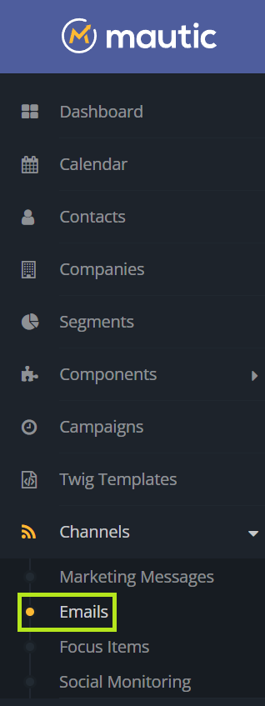

You’ll be brought to the central email screen where you can click ‘New’ to create a new email.

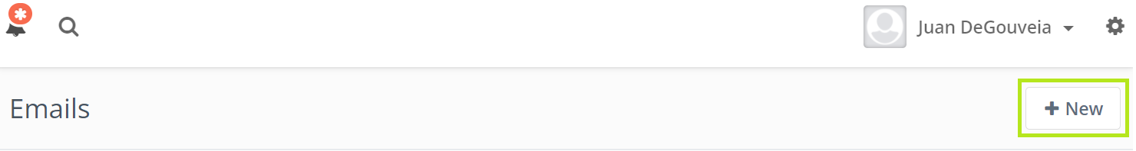

From there, you’ll be asked what type of email you want to create. In this case, select ‘New Template Email.’

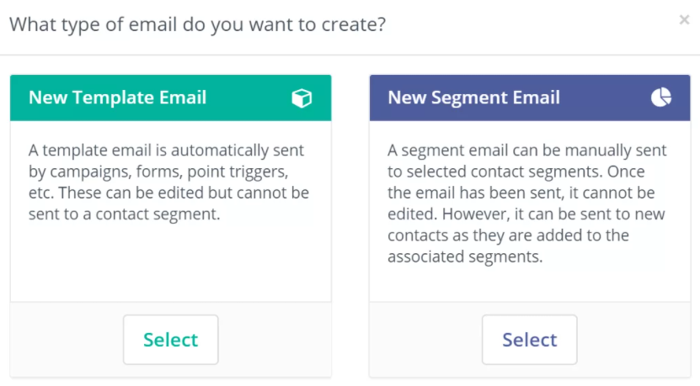

You’ll then be brought to an email builder which provides plenty of options for customizing the template.

**Select Your Template Theme**

First, you can select your template from the various themes available in Mautic. You could also code or import your own template if you so choose.

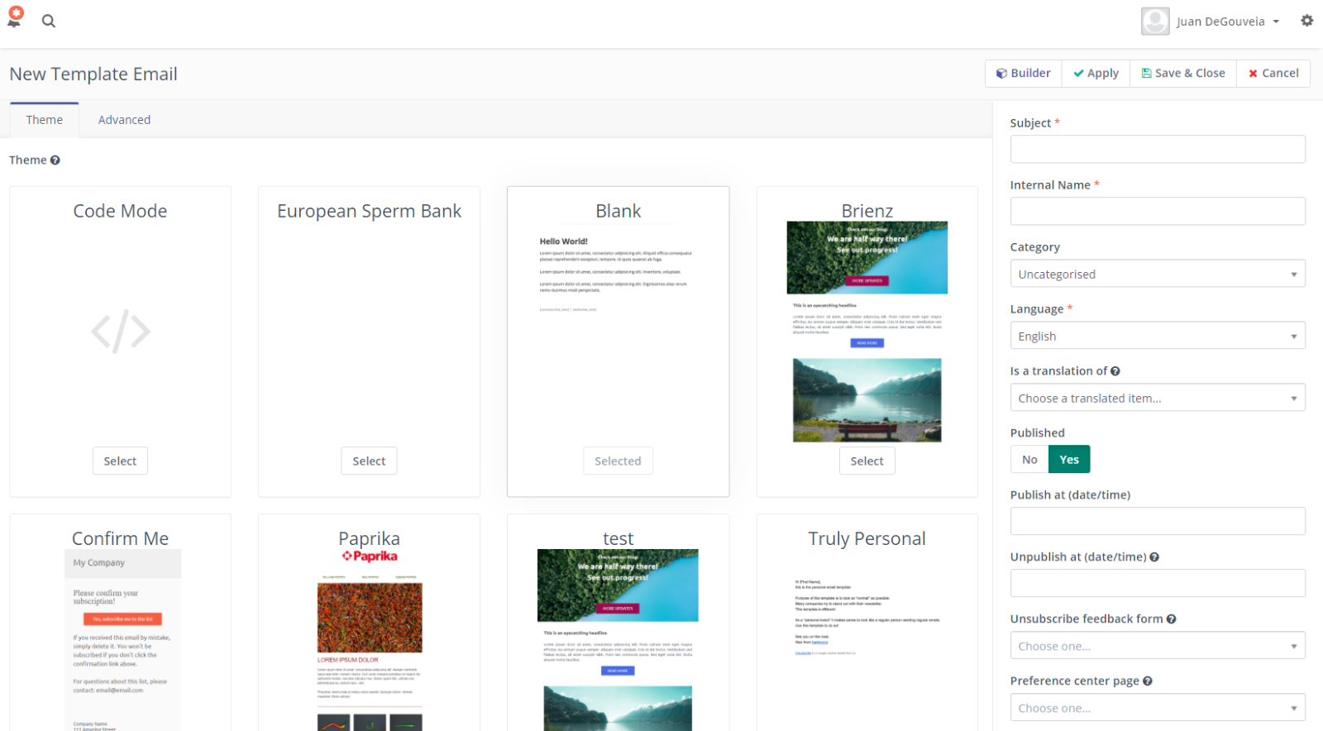

**Adding Email Details**

On the right-hand menu, you’ll find a number of different fields that allow you to schedule, track, and organize your email campaigns. There, you can select which segment your email will be sent to, and add details such as an internal name for your campaign and custom UTM tags.

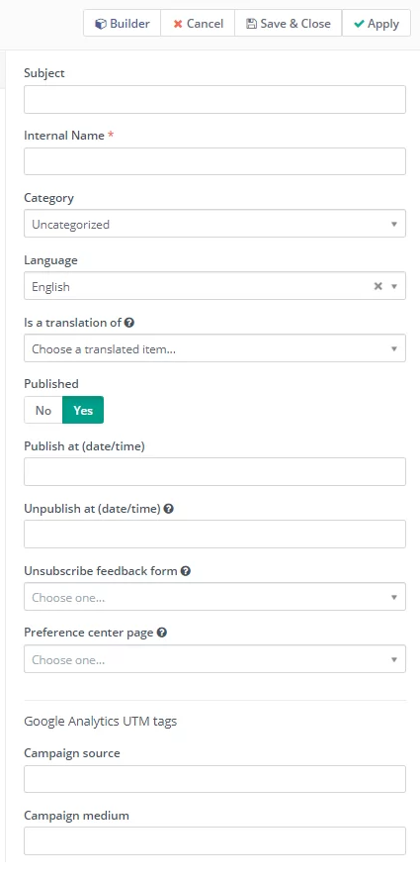

**Advanced Email Settings**

To further customize your email, click the ‘Advanced’ button in the top left-hand corner. There, you can select the ‘reply to address,’ add attachments, and create a plain text version of your email if you so choose.

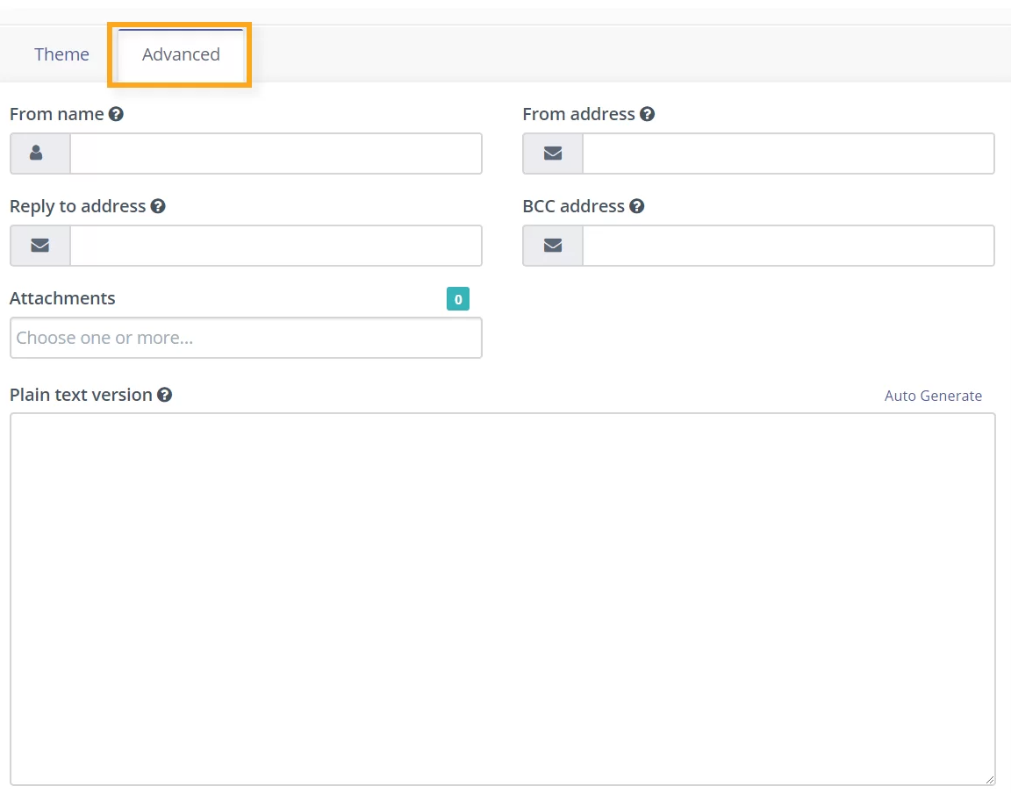

**Creating Email Content**

Once you’ve selected a template and added any necessary details, the next step in building an email in Mautic is to add the content itself. To do so, click ‘Builder’ in the top right-hand corner.

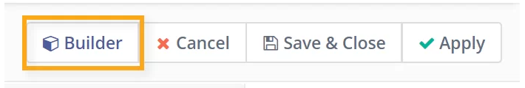

To edit a pre-existing element, simply click on it. You can then make any necessary changes in the “Blocks” section or in the “Style manager” section on the right-hand side. Your changes will automatically update in the preview version of your email.

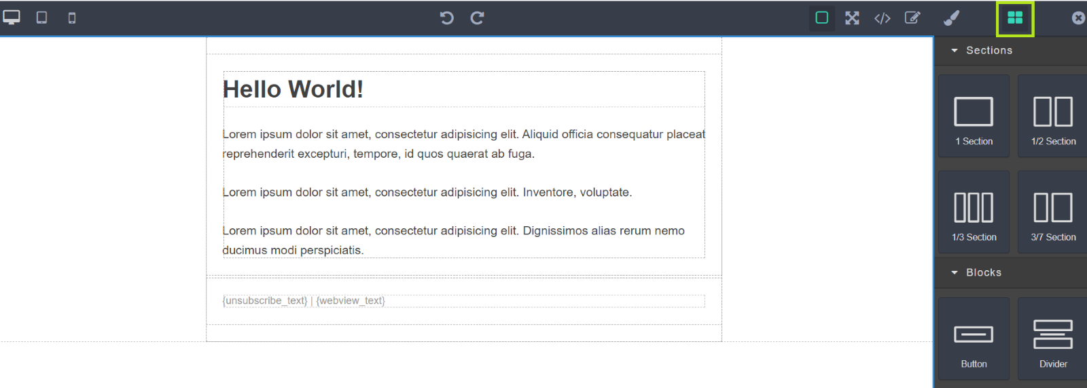

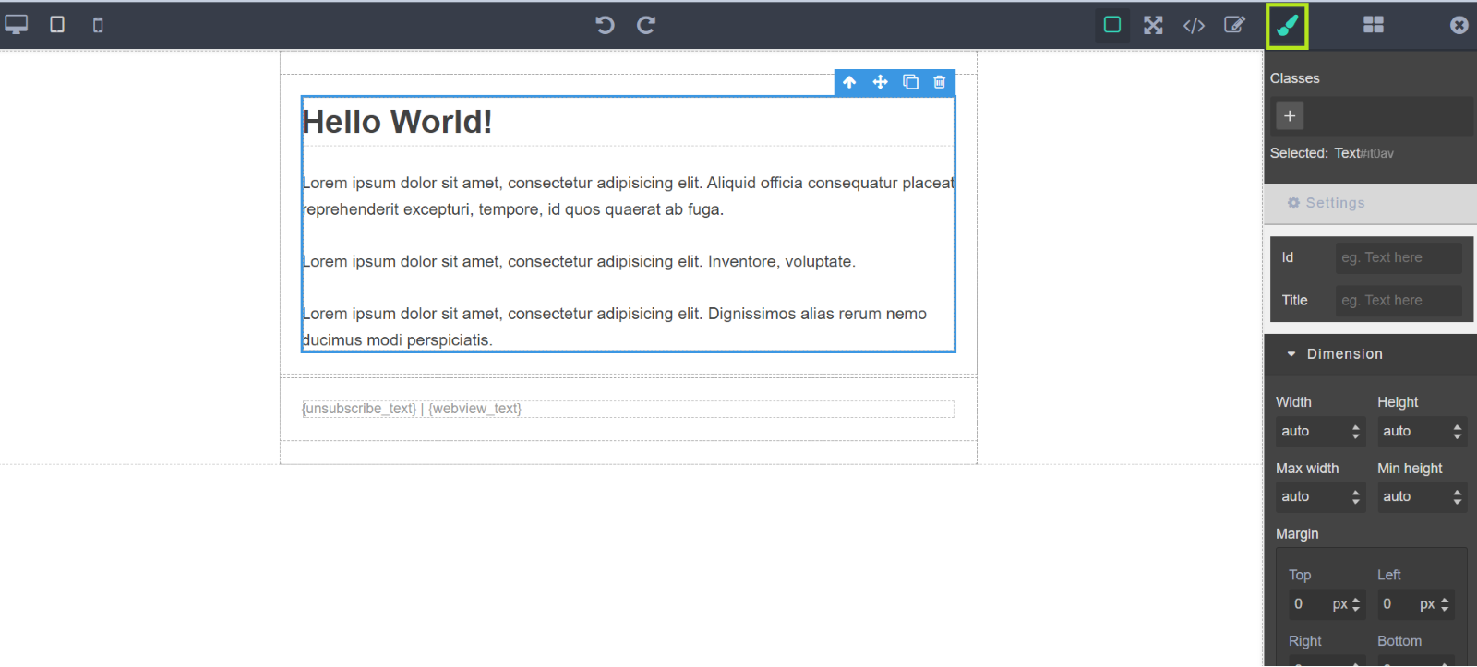

**Twig templates**

One of the features that we can take advantage of Mautic, is the installation of the plugin "Twig template".

Twig is a modern template engine for PHP, is a library designed to combine templates with a data model to produce documents.

We can use the features provided by the twig templates to be used within our emails, this way we can create reusable layouts/components in our emails.

**Installation**

* Download last version
* Unzip files to plugins/MauticTwigTemplatesBundle
* Clear cache (app/cache/prod/)
* Go to /s/plugins/reload
* Enable TwigTemplates plugin

**Usage**

To create a new twig template, go to the left sidebar, click on 'Twig templates' and then click on "New".

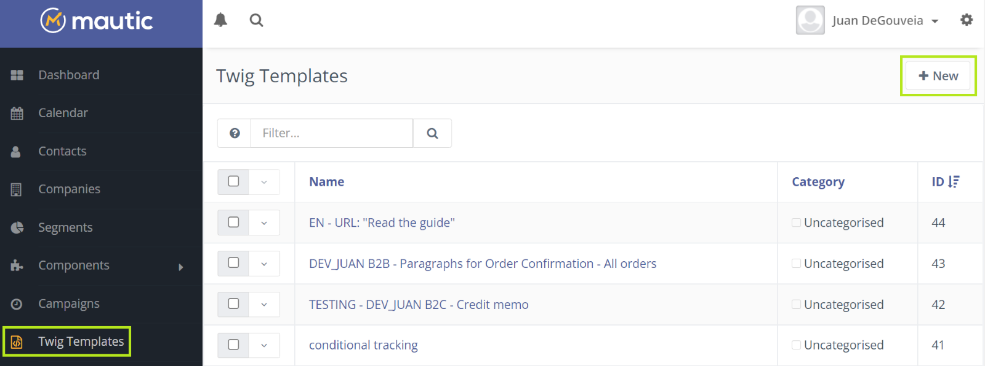

In this section we can assign the name of our twig template and we are able to code with twig syntax ([Learn more](https://twig.symfony.com/doc/3.x/)).

For example:

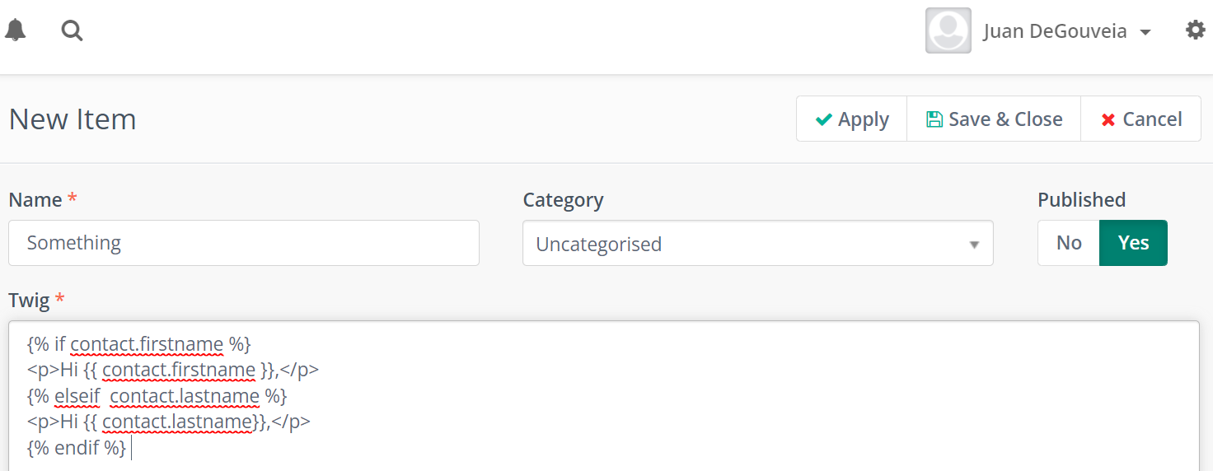

To integrate our previously generated twig template into our emails, we must define it with the following syntax {twigtemplate=id} ("id", refers to the id of the twig template) in our email.

For example:

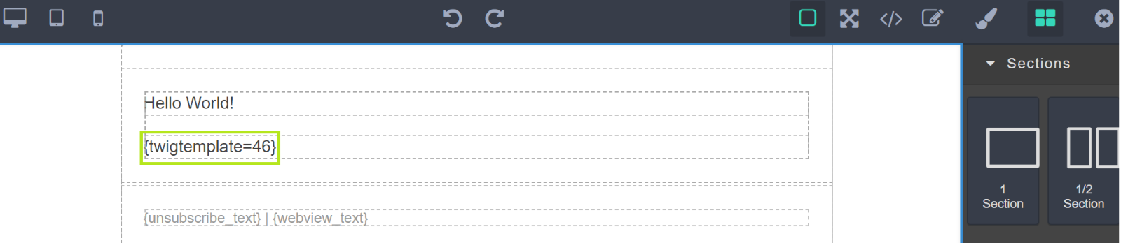

**Campaigns:**

Prerequisites:

* Create a form or segment to initialize the campaign.
* Create any custom fields that may need adding to the contacts profile.
* Create any assets, landing pages or other components that will be used in the campaign.

Create the Campaign:   
  
1. Launch your Mautic instance.

2. Click Campaigns on the left navigation menu.

3. Click New to create a new Campaign

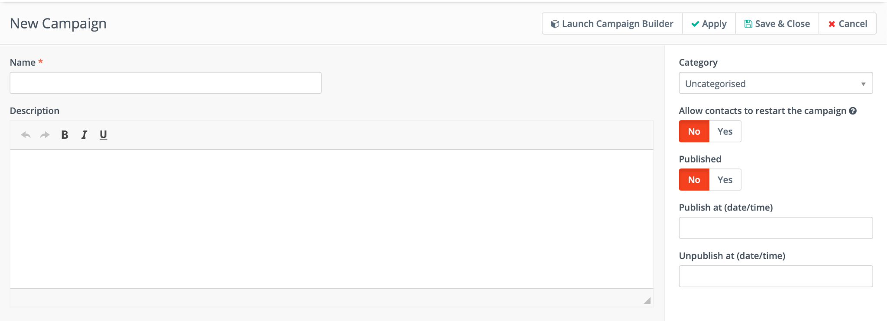

4. Give the Campaign a name (remember to use proper naming convention)

5. Click Launch Campaign Builder to start building the campaign.

6. Click add a contact source.

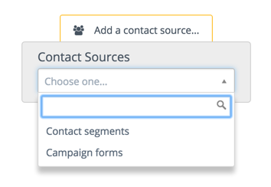

Contacts can be triggered from segments or forms. Choose contact segments if you want to target contacts that share a specific attribute such as “located in the UK”. Choose campaign forms if you want to start the campaign once the user completes a form such as a newsletter sign up form.

You can select a mix of both contact source types by clicking the gray selector once chosen.

7. After selecting a contact source you can then select the bottom gray selector to choose an event.

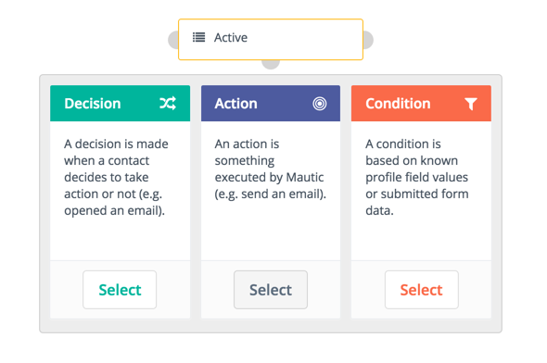

**Unsubscribe Example Campaign:**   
  
For this example I have created an unsubscribe form within Mautic which is selected as the contact source in the campaign.

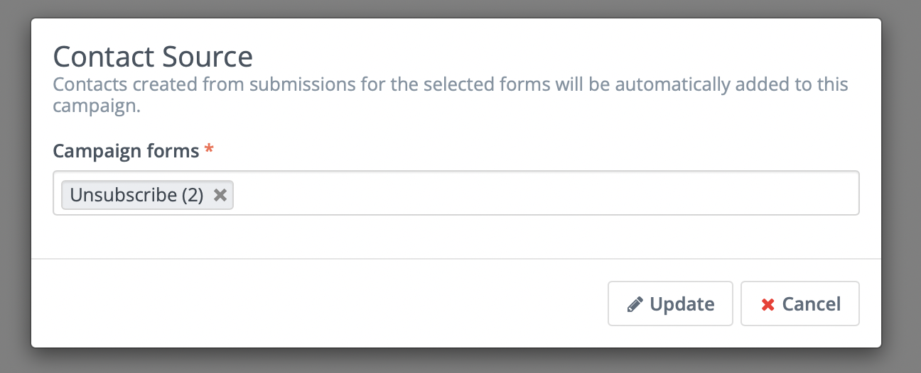

The next step was to add an “Do Not Contact” action which is then linked to a segment. Every user who fills out the form gets added into the segment and is then unsubscribed from emails.

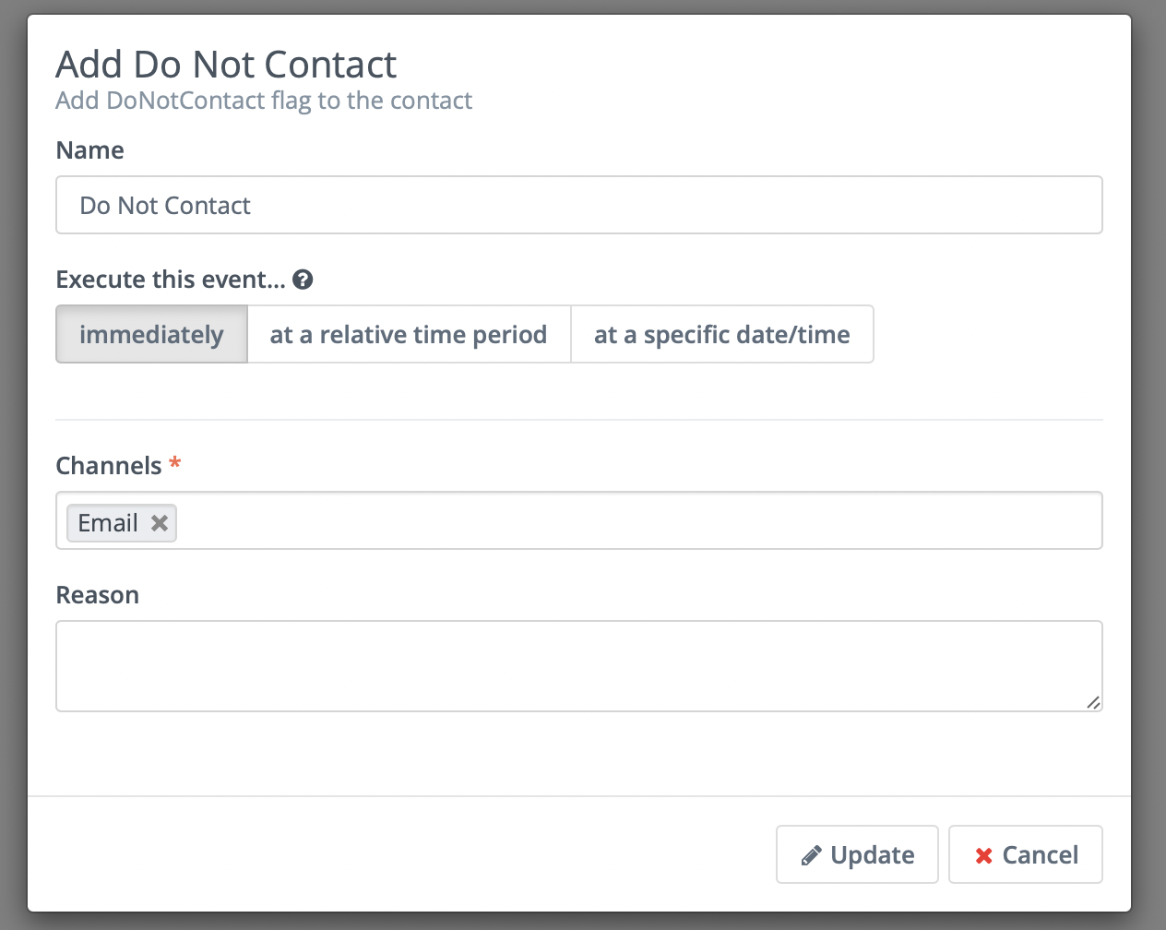

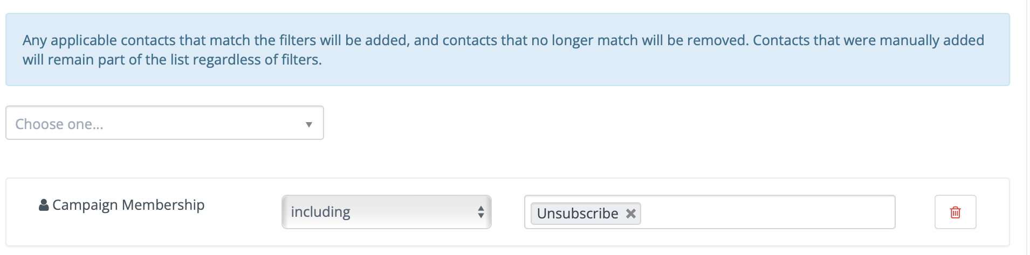

**Forms**

* Navigate to components - forms. New form.
* Select campaign form to use the form in a campaign.
* Give the form a name.
* Start adding fields into the forms, you can change the label, change whether you want the label to show, give class names and change the validation for each field.

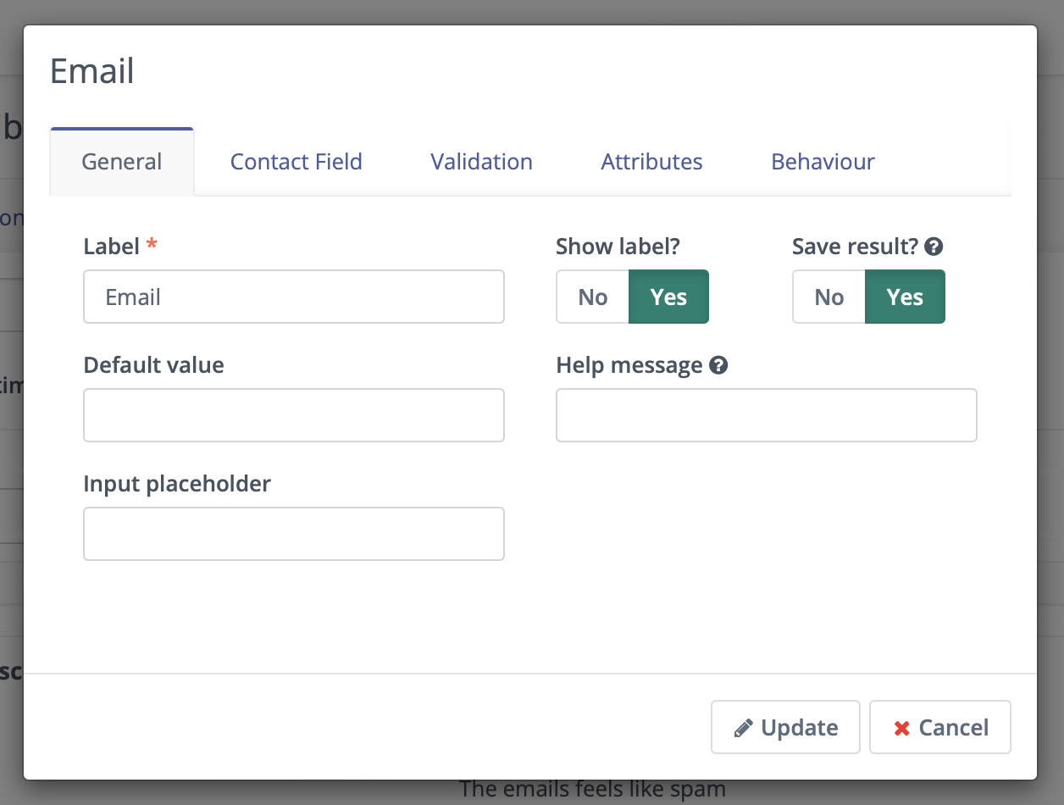

* You can select an action once the user has completed the form. For example if a user subscribes to your newsletter you can choose “send email to user” to send a confirmation email.

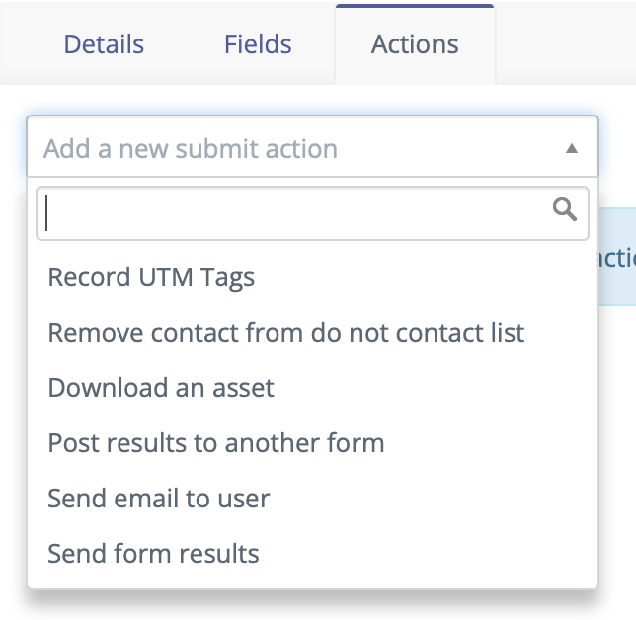

**Themes**

Installing a new theme:

* Navigate to the settings icon in the top right and then click themes.
* Click choose file and click your theme in .zip format and click upload.
* This theme will now be installed.

You can also download any of the pre-installed themes from this page. Themes can also be edited and re-uploaded however be aware that they will return to the default theme after new updates.

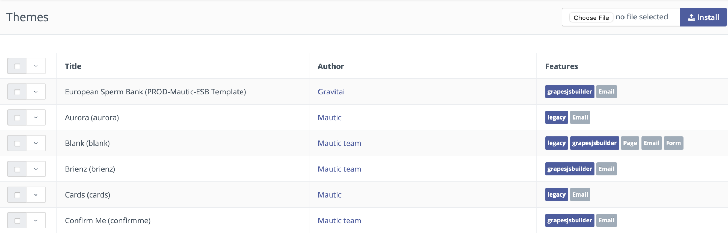

**Dynamic Content**

Dynamic content can be used within emails & landing pages.

A list tokens that can be used within emails & landing pages - <https://docs.mautic.org/en/setup/variables>

**Landing Pages**

* Navigate to components - Landing Pages.
* Click New to add a new landing page.
* Add a title and click builder to start building the landing page.

